**1.Churn Analysis: Identify churned customers and their demographics:**

select City,Country,count(c.Customer_ID) as Churnedcustomer,avg(a.Balance) as Churnedcustomerbalance

from Customers c inner join Accountss a

on c.Customer_ID=a.Customer_ID

where c.Churned='Yes'

group by City,Country

order by Churnedcustomer;

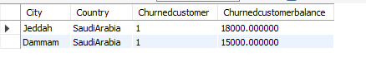

2.Customer Segmentation by Balance:

select c.Customer_ID,c.Name,

case

when a.Balance<16000 then 'Bronze'

when a.Balance between 16000 and 30000 then 'silver'

when a.Balance>30000 then 'gold' end as balancetier

from Customers c inner join Accountss a

on c.Customer_ID=a.Customer_ID;

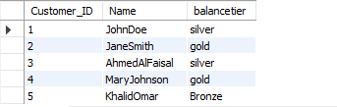

3.SELECT c.Country, AVG(Loan_Amount) AS Avg_Loan, AVG(Interest_Rate) AS Avg_Interest,

COUNT(CASE WHEN Defaulted = 'Yes' THEN 1 END) AS Defaulted_Loans

FROM Loans l inner join Customers c

on l.Customer_ID=c.Customer_ID

GROUP BY c.Country

ORDER BY Defaulted_Loans DESC;

